|  |  |  |
| --- | --- | --- |
|  |  |  |

**PROJECT**: PHEIDIP SHOP **GROUP NO:** 05 **BATCH:** T1.2112.E0

**A. System requirement:**

|  |  |  |
| --- | --- | --- |
| **Sr.** | **Item** | **Description** |
| 1. | OS | Windows 7 or better |
| 2. | Database | MySQL Server 2008 or later |
| 3. | Software | XAMPP, WAMP or the same  Internet Browser (Chrome, Opera, Firefox, ...) |

**B. Setup MySQL:**

1. Dowload XAMPP and Setup

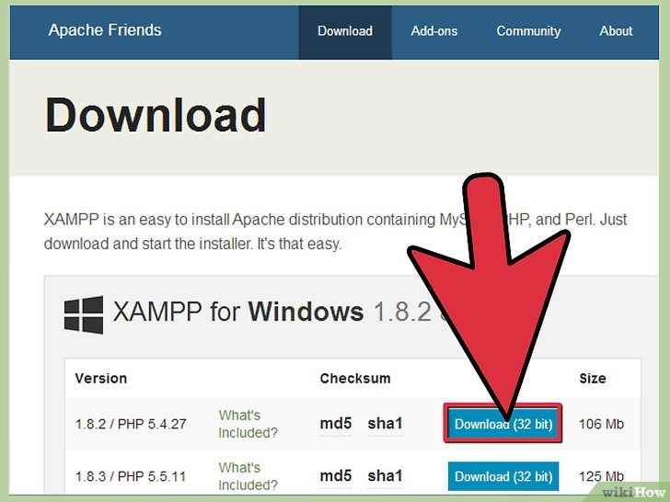

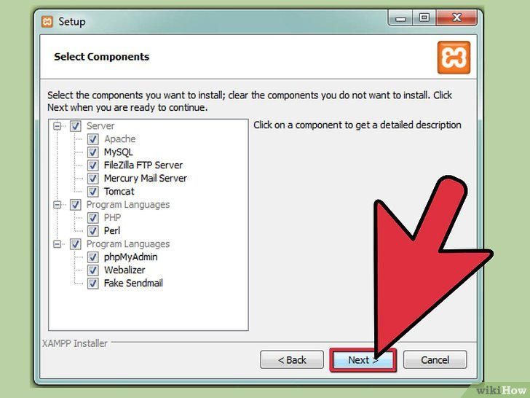

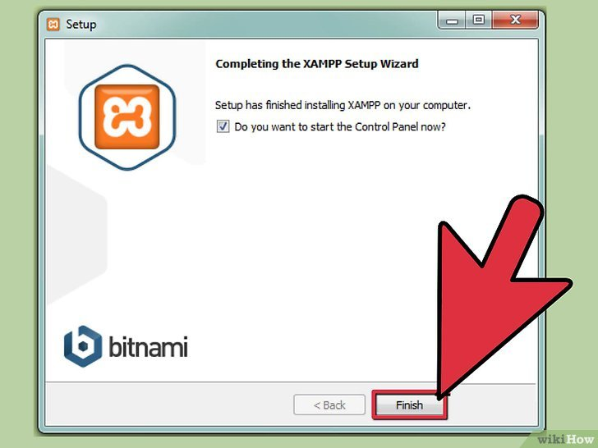

**C. Setup Database**

1. Open XAMPP Panel, Start Apache and MySQL

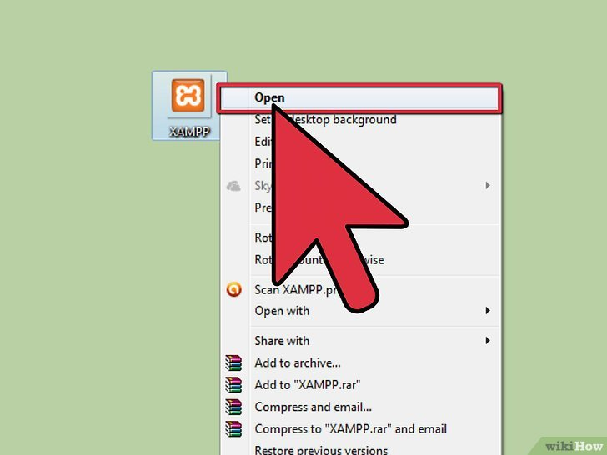

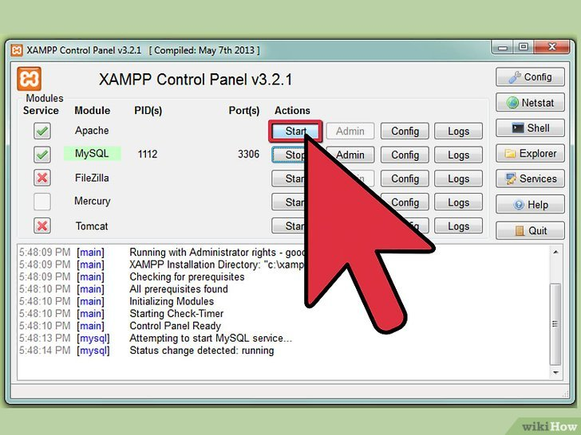

1. Click Admin button of MySQL

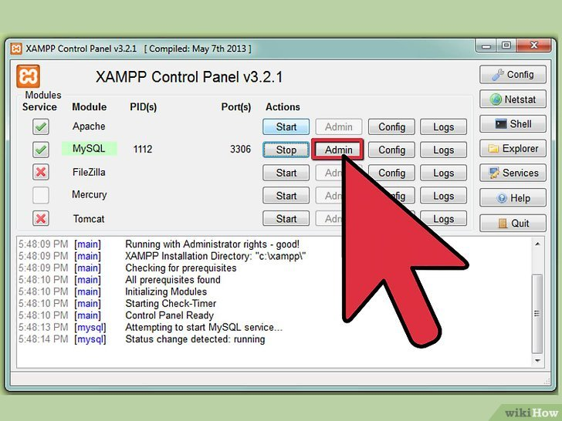

1. Copy database script, paste to SQL window and click go.

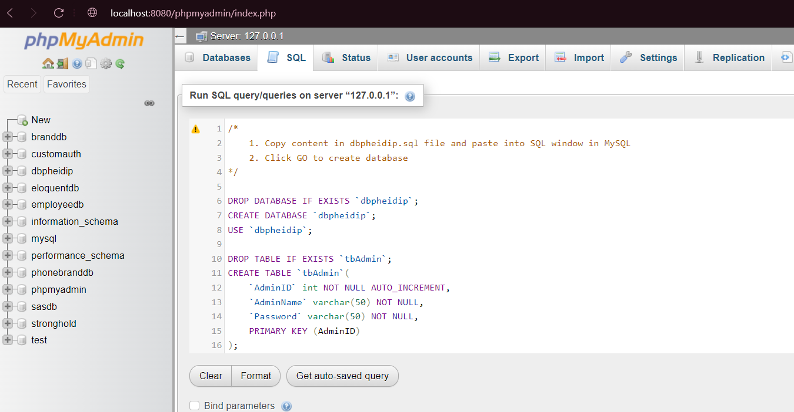

1. Sucess

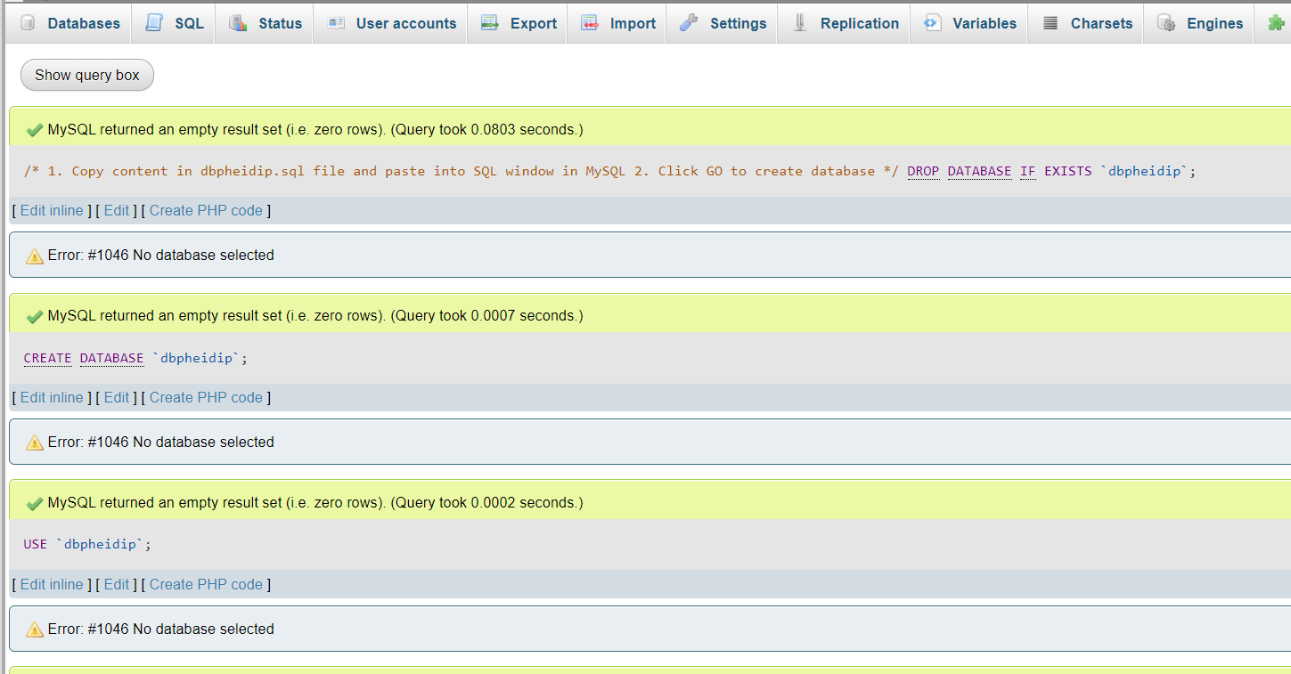

**D. Installation successful:**

- Clone Pheidip Shop Project from github or copy/pates it to htdocs folder.

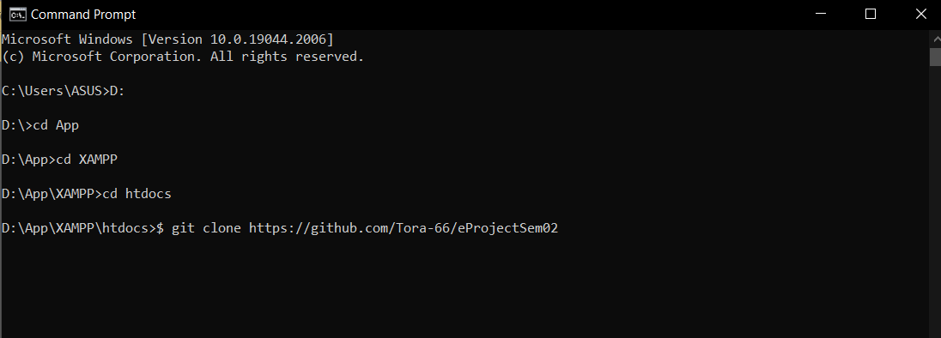

- Open Browser, type url

+ User : “localhost/” + path of Phedip Shop Project + “home.php”

(example: http://localhost/PheidipShop/home.php)

+ Admin : “localhost/” + path of Phedip Shop Project + “admin.php”

(example: http://localhost/PheidipShop/admin.php)

- Login information:

+ User:

* User Name : user01
* Password : User01

+ Admin:

* User Name : admin
* Password : 123

